**COLLEGE MANAGEMENT SYSTEM**

# A Project submitted in partial fulfillment of the requirements for the Degree

***of***

Master in Computer Application

## Submitted

**By**

### Girish Chandra Sahoo

**Regd. No.(s) – 2105219032**

***Paramjit Singh***

**Regd. No.(s) – 2105219049**

***Giridhari Samal***

**Regd. No.(s) – 2105219031**

***Priyabrata Naik***

**Regd. No.(s) – 2105219054**

#### *Under the Guidance of*

##### Mr. Biswajit Swain



**P.G. Department of Computer Science & Applications**

**COLLEGE OF ENGINEERING BHUBANESWAR, BHUBANESWAR**

***(An Affiliated College of Biju Patnaik University of Technology, ODISHA*)**

**COLLEGE OF ENGINEERING BHUBANESWAR (CEB)**

**Plot No -1, Sector-B, Chandaka Nucleus Complex, Patia, Bhubaneswar 751024**

**Phone: (0674) 2740133/2740386, www.ceb.ac.in**

Ref. No. 2105219032 Date: 24/07/2023

**To Whom So Ever It May Concern**

This is to certify that **Girish Chandra Sahoo, Paramjit Singh, Giridhari Samal , Priyabrata Naik**  bearing University Regd. No**. 2105219032 , 2105219049 , 2105219031 , 2105219054** respectively ,has carried out the Project / Dissertation work entitled College Management System at College of Engineering Bhubaneswar from ________ to ________ , and successfully completed under my guidance and supervision, towards partial fulfillment of award of degree of Master in Computer Application.

Internal Guide

**COLLEGE OF ENGINEERING BHUBANESWAR (CEB)**

**Plot No -1, Sector-B, Chandaka Nucleus Complex, Patia, Bhubaneswar 751024**

**Phone: (0674) 2740133/2740386, www.ceb.ac.in**

Ref. No. 2105219032 Date: 24/07/2023

***CERTIFICATE***

This is to certify that the project work entitled College Management Systemcarried out by **Girish Chandra Sahoo**, **Paramjit Singh , Giridhari Samal , Priyabrata Naik** ,under our guidance bearing **Regd.No-2105219032, 2105219049 , 2105219031 , 2105219054** respectively , students of 2nd year MCA from College of Engineering Bhubaneswar, Bhubaneswar, has been completed by their and worthy of acceptance for the degree of Master in Computer Application, under Biju Patnaik University of Technology, Rourkela, Odisha.

**Internal HOD External**

**Examiner Department of Examiner Computer Science**

**& Applications**



ACKNOWLEDGEMENT

I would like to express my profound gratitude to **Mr. B.B. Biswal**, of HOD Of Master Of Computer Application department, for their contributions to the completion of my project **College Management System**.

I would like to express my special thanks to our mentor **Mr. Biswajit Swain** for his time and efforts he provided throughout the year. Your useful advice and suggestions were really helpful to me during the project’s completion. In this aspect, I am eternally grateful to you.

I would like to acknowledge that this project was completed entirely by me and not by someone else.

Girish Chandra Sahoo

Paramjit Singh

Giridhari Samal

Priyabrata Naik

**(Name of the student)**

**DECLARATION**

We **Girish Chandra Sahoo, Paramjit Singh , Giridhari Samal , Priyabrata Naik** hereby that the project entitled College Management System is completed by us at College of Engineering, submitted to College Of Engineering, Bhubaneswar for fulfilling the requirements for the MCA course during the session 2021-2023. I submitted the project report to “BPUT”.









Place: Bhubaneswar

Date: 24/07/2023 Signature

**CONTENTS**

1. **Project Title 1**
2. **Certificate 2**
3. **Acknowledgement 3**
4. **Declaration 4**
5. **Abstract 5**
6. **Main Module Of System 6**
7. **Objective & Scope of the Project 7**
8. **Theoretical Background 8**
9. **Definition of Problem and Solution 9**
10. **Steps on how to run the project 18**
11. **Study of The System 21**
12. **System Requirements 22**
13. **System Planning (PERT Chart) 23**
14. **Methodology adopted, System Implementation & Details of H/W& S/W used 25**
15. **Details Life Cycle of Project 26**
16. **ERD, DFD 29**
17. **Input and Output Screen Design(Snapshots) 30**
18. **Conclusions 50**
19. **References**  **51**

**LIST OF FIGURES**

1. **Waterfall Model Figure of Details Life Cylcle Of Project 20**
2. **0-Level Data flow Diagram 25**
3. **1- Level Data Flow Diagram 30**
4. **2-Level Data Flow Diagram 33**
5. **ER-Diagram of Collge Mangement Syatem 35**
6. **Home Page of Project 37**
7. **Login Page of Project 40**
8. **Admin Dashboard Page 42**
9. **Enter Student Result Dashboard 45**
10. **Teacher Dashboard Page 46**
11. **View Student Attendance 47**
12. **Student Result Page 48**
13. **View Student Result and Print Result 49**

**ABSTRACT**

Online College Management System (OCMS) provides a simple interface for maintenance of student information. It can be used by educational institutes or colleges to maintain the records of students easily. The creation and management of accurate, up-to-date information regarding a students’ academic career is critically important in the university as well as colleges. Student information system deals with all kind of student details, academic related reports, college details, course details, curriculum, batch details, placement details and other resource related details too. It will also have faculty details, batch execution details, students’ details in all aspects, the various academic notifications to the staff and students updated by the college administration. It also facilitate us explore all the activities happening in the college, Different reports and Queries can be generated based on vast options related to students, batch, course, faculty, exams, semesters, certification and even for the entire college The placement officer is responsible for updating the placement related information like eligible criteria for a particular company, arriving date for the company which is coming for recruitment, the list of students who are eligible for attending the recruitment process. E-Library (also referred to as digital library) is a special library with a focused collection of digital object

**MAIN MODULE OF THE SYSTEM**

1. **Student Module**: This module used to store student records. It contains the following information i.e. Students Profile details, Contact information, Educational details, etc. The Users can search the students from the database according to different criteria such as name, Course, Roll number, etc.
2. **Admin Module**: The first step in this application is to get the staff members and teaching faculty to register. They need to first register then they t provide his or her  id and password for login.
3. **Admin Login**: After registering the admin is allowed to log in. He or she can now view admin homepage where there are options to take attendance, upload results, send notifications to student. He can also view the attendance taken and uploaded results.
4. **Faculty and Student Attendance**: The college management system should have this module to check faculty and student attendance. This will record the everyday attendance and  activities of everyone in the college. The attendance data will be stored in the collage database. The generated data will be stored for future use.
5. **Course Module**: The courses and subject management  module will do the assigning  of subjects for every course that the college offers. This module will also bracket the schedules of each subject and the instruction that handle each subject.
6. **Check Notifications**: Faculty can receive important announcements, information regarding meetings from the HOD or admin through these notifications.

**Objective & Scope**

## 1.1 Objective

This is a web-oriented application allows us to access the whole information about the college, staffs, students, facilities etc. This application provides a virtual tour of Campus. Here we will get the latest information about the students and staffs. This generic application designed for assisting the students of an institute regarding information on the courses, subjects, classes, assignments, grades and timetable. It also provides support that a faculty can also check about his daily schedule, can upload assignments, and notices to the students. Here administrator will manage the accounts of the student and faculties, makes the timetable, and upload the latest information about the campus.

## 1.2 Scope

* College information: Through this service one can access the complete information about the college campus such as courses available, admission procedure, placements, college events, achievements etc.
* Student tracking: Any company or any organization that want to check the summary about the student of the college, so that they will be able to choose the particular students for their campus placement And for that purpose they will be given a particular link through which they can access the information required.
* Student attendance status: It gives the attendance status of students. Faculty will update the attendance periodically and can be seen by students and parents.
* Student’s performance in exams: This facility provides the performance of the student in each exam which is conducted by university or college such as midterm performance. Marks obtained by students in exams will be updated by faculties that can be access by students and parents.
* Exam Notification: This facility notifies students and parents about examination schedule.
* Events: It will give information about different events that will be conducted by college time to time. Information about these events will be updated by administrator.
* Online assignments: This service provides the facility to faculty to upload assignments and to students to submit these assignments online.
* Information about staff: It will help in maintaining complete information about college faculty members such as their department, cadre, date of joining, salary, etc. Administrator will register new faculties and remove their account when they leave the college.

**Theoretical Background**

Today in colleges student details are entered manually. The student details in separate records are tedious task. Referring to all these records and updating is needed. There is a chance for more manual errors.

**Problems in existing system:**

* It was limited to a single system.
* It was less user-friendly.
* It have a lots of manual work (Manual system does not mean that we are working with pen and paper, it also include working on spread sheets and other simple software's)
* It requires more no of employees need to work.
* It was time consuming process.
* The present system was very less secure.
* It is unable to generate different kinds of report.

**Solution to these problems:**

The development of the new system contains the following activities, which try to automate the entire process keeping in view of the database integration approach.

* User friendliness is provided in the application with various controls.
* The system makes the overall project management much easier and flexible.
* It can be accessed over the Internet.
* Various classes have been used to provide file upload and mail features.
* There is no risk of data mismanagement at any level while the project development is under process.
* It provides high level of security using different protocols like https etc.

**Problem Definition And Solution Definition**

***Problem Definition***

The problem is to provide the complete information about the college campus. In which the college staff members, students and parents can access the information and will be familiar with college campus. It will provide interactive environment for the staff, students and parents by getting knowledge of student attendance, remarks, exams performances, grades, notices etc.

Manually recording attendance and Fees is very time-consuming. As a consequence, performance and productivity can be affected. The manual process of collecting attendance data for all your Students will also take time. You might also end up spending a lot of time maintaining scorecards, rectifying errors in time entry, and so on.

***Solution Definition***

It frees you from the burden of having to keep an eye on attendance by automating the task. The system collects and stores the attendance and Fees data of all the Students for you. Using the stored data, you can track Students attendance and determine how many hours they have attended Classes etc . eventually saving time and increasing productivity.

## ****College Management System Project In PHP and MySQL**** :

## Steps on how to run the project

Time needed: 5 minutes.

These are the steps on how to run **College Management System Project In PHP and MySQL**

* **Step 1: Create Project Folder**

Next, copy the project folder and paste it to **C:\xampp\htdocs**.

* **Step 2: Open Xampp**

Next, open **xampp** and start the **Apache** and **MySQL**.

* **Step 3: Create Database**

Next, click any browser and type to the URL ***localhost/phpMyAdmin*** and create database.

**• Step 4: Import Database**

Next, click the created database and click import to the right tab and click choose file and import the SQL file inside the download folder.

* **Step 6: Execute Project**

Final, type to the URL **localhost/college**

**Study of the System:**

**11.1 Graphical user interface**

In the flexibility of the uses the interface has been developed a graphics concept in mind, associated through a browses interface. The GUI’S at the top level have been categorized as

1. Administrative user interface
2. The operational or generic user interface

The administrative user interface concentrates on the consistent information that is practically, part of the organizational activities and which needs proper authentication for the data collection. The interfaces help the administrations with all the transactional states like Data insertion, Data deletion and Date updation along with the extensive data search capabilities.

The operational or generic user interface helps the users upon the system in transactions through the existing data and required services. The operational user interface also helps the ordinary users in managing their own information helps the ordinary users in managing their own information in a customized manner as per the assisted flexibilities.

# 11.2 Number of Modules

The system after careful analysis has been identified to be presented with the following modules:

The modules involved are:

1. **College information**: Through this service one can access the complete information about the college campus such as courses available, admission procedure, placements, college events, achievements etc.
2. **Student attendance status**: It gives the attendance status of students. Faculty will update the attendance periodically and can be seen by students and parents.
3. **Exam Notification**: This facility notifies students and parents about examination schedule.
4. **Events**: it will give information about different events that will be conducted by college time to time. Information about these events will be updated by administrator.
5. **Information about staff**: It will help in maintaining complete information about college faculty members such as their department, cadre, date of joining, salary, etc. Administrator will register new faculties and remove their account when they leave the college.

**SYSTEM PLANNING (PERT CHART)**

Perform and evaluate feasibility studies like cost-benefit analysis, technical feasibility, time feasibility and operational feasibility for the project. Project Scheduling should be made using PERT charts.

Feasibility study is carried out t decide whether the proposed system is feasible for the company. The feasibility study is to serve as a decision document it must answer three key questions:

1. Is there a new and better way to do the job that will benefit the user?
2. What are the cost and the savings of the alternative(s)?
3. What is recommended?

**Technical feasibility:**

Technical feasibility centers on the existing computer system i.e. Hardware, Software etc. Bank requires SQL database management that are all easily available with extensive development support through manuals and blogs.

**Economical feasibility:**

Economical Feasibility is the most frequently used method for evaluating the effectiveness of a candidate system. More commonly known as Cost/ Benefit analysis, the procedure is to determine the benefits and savings that are expected from the candidate system and compare them with costs. If the benefits outweigh costs, then the decision is made to design and implement the system.

**Methodology Adopted, System Implementation & Details of Hardware & Software Used**

**13.1 Methodology adopted and System implementation:**

1. Apache tomcat is used as a web server to host the application.
2. All the environment variables are set.
3. The application is pasted in the webapps folder.
4. Web server is started now.
5. Application is run using the web browser by typing http://localhost/cis
6. Web.xml file is used to control the flow and user actions.

**13.2 Details of hardware & software used:**

**Hardware Specification** :

**Disc Space:** 1TB

**PC Used:** Dell Vostro 3590

**Processor:**  Core i5 10th Gen

**Memory:** 8GB RAM

**File System:** 64 Bit

**Software Specification:**

**Operating System (Server Side):** Windows 11.

**Operating System (Client Side) :** Windows 11.

**Client End Language :** HTML , CSS , JavaScript

**Local Validation :** PHP

**Server-Side Language :** PHP

**Database :** **MySQL Server 8.0. 32**

**Web Server :** XAMPP server

**Web Browser :** Google Chrome/Microsoft Edge

**DETAILED LIFE CYCLE OF PROJECT**

We have used Waterfall Model as Software Engineering life Cycle Process. It is the simplest; oldest and most widely used process model for software development .This model acquires its name from the fact that classic software life cycle is represented as a sequence of descending steps.

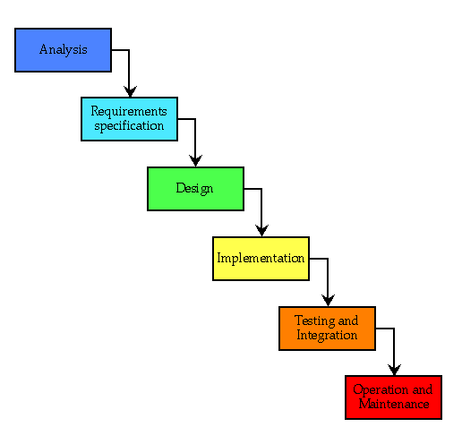

**14.1 Requirement Analysis:**

This process is also known as feasibility study. In this phase, the development team studied the site requirement. They investigate the need for possible dynamic representation of the site and increase security features. By the end of feasibility study, the team furnishes a document that holds the different specific recommendations for the candidate system. It also includes personnel assignments, costs, project schedules, target dates etc. the requirement gathering process is intensified and focused specially on software. The essential purpose of this phase is to find the need and to define the problem that needs to be solved. During this phase following facts were gathered.

* Determined the user need
* Identified the facts
* Establish the goals and objective for the proposed system
* Feasibility for the new system

**14.2 System Analysis and Design:**

In this phase the software’s overall structure and its nuances are defined. In terms of client server technology the no of tiers needed for the package architecture, database design, data structure design etc are defined in this phase. Analysis and Design are very crucial in entire development cycle. Any glitch in this phase could be expensive to solve in the later stage of software development. Hence following is the essential approach taken during website designing:

* DFD
* Database Designing
* Form Designing
* Pseudo code for methods

**14.3 Testing:**

Once the code is generated, the website testing begins. Different testing methodologies are done to unravel the bugs that were committed during the previous phases. Different testing methodologies are used:

* Acceptance testing
* White Box Testing
* Black Box Testing

**DFD and ER For College Management System**

**15.1 DFD**

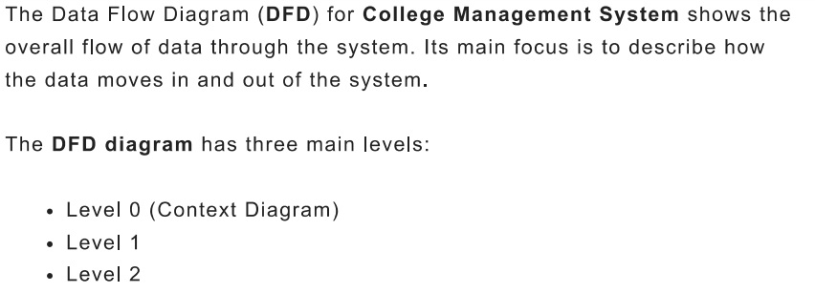

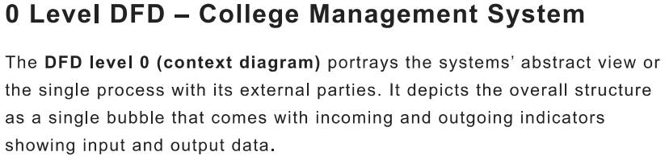

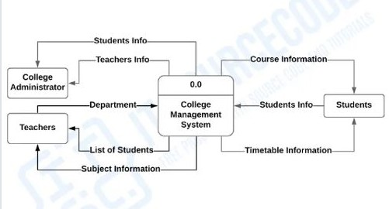

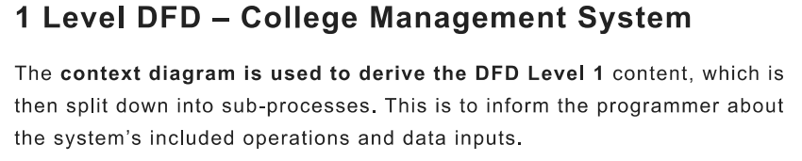

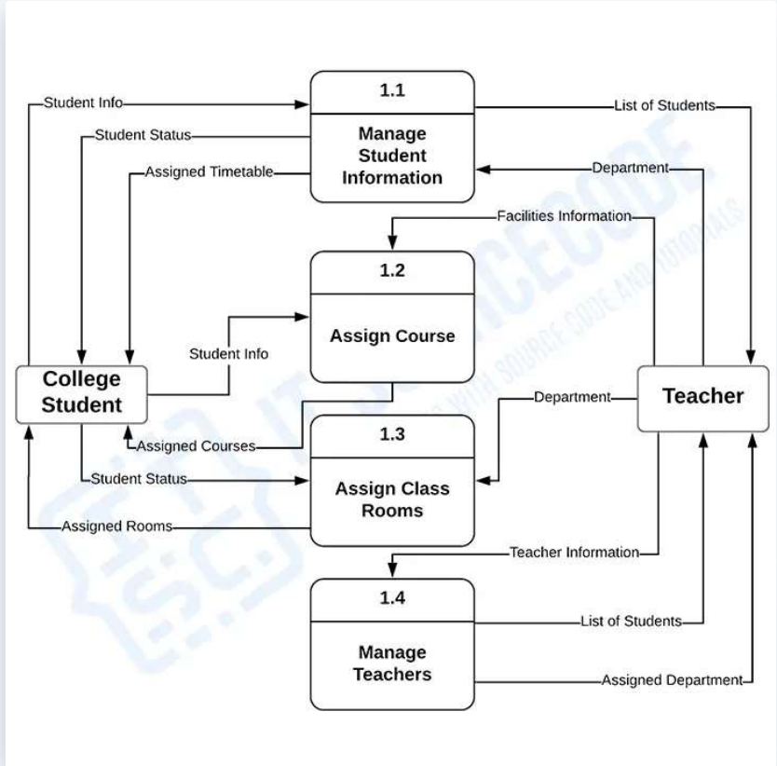

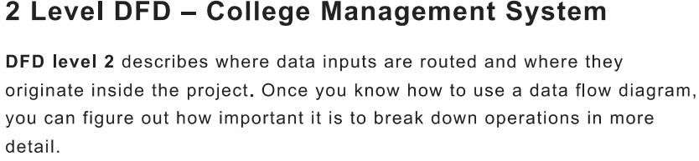

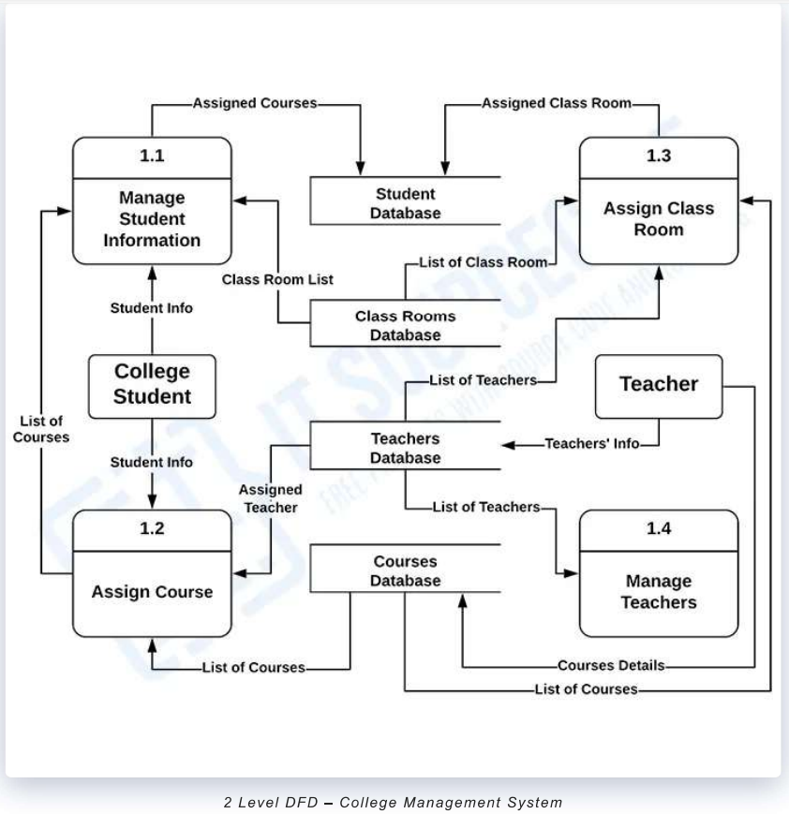

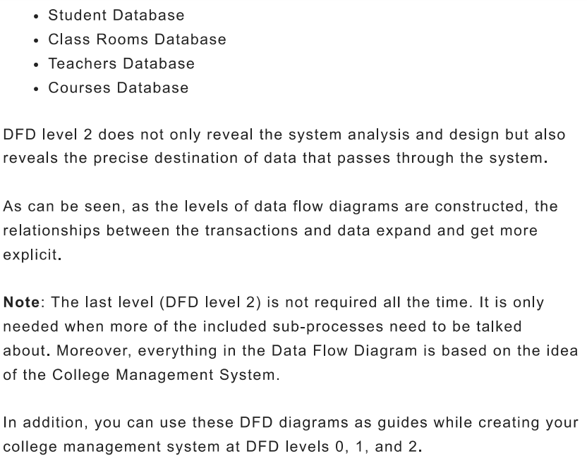

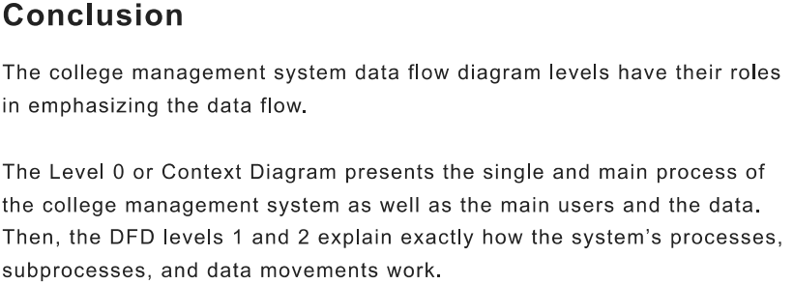

**ER Diagram Of College Management System**

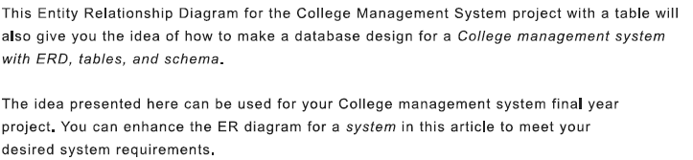

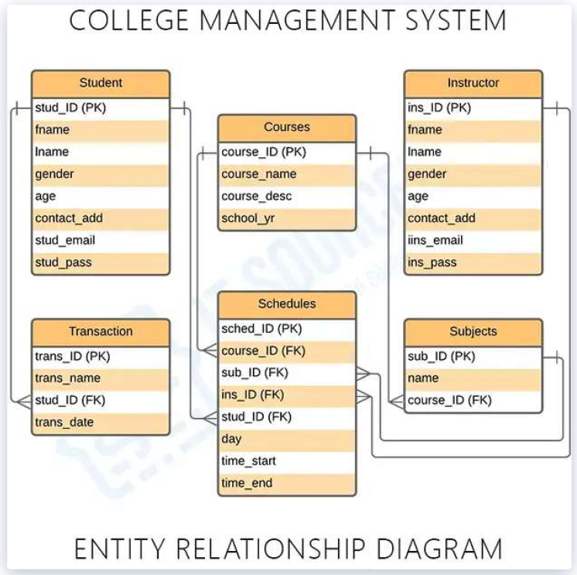

**Input and Output Screen Design (Codes)**

**Home Page: - http://localhost/SAMS/Mentor/College.php**

<!DOCTYPE html>

<html lang="en">

<head>

  <meta charset="utf-8">

  <meta content="width=device-width, initial-scale=1.0" name="viewport">

  <title>College Management System</title>

  <meta content="" name="description">

  <meta content="" name="keywords">

  <!-- Google Fonts -->

  <link href="https://fonts.googleapis.com/css?family=Open+Sans:300,300i,400,400i,600,600i,700,700i|Raleway:300,300i,400,400i,500,500i,600,600i,700,700i|Poppins:300,300i,400,400i,500,500i,600,600i,700,700i" rel="stylesheet">

  <!-- Vendor CSS Files -->

  <link href="assets/vendor/animate.css/animate.min.css" rel="stylesheet">

  <link href="assets/vendor/aos/aos.css" rel="stylesheet">

  <link href="assets/vendor/bootstrap/css/bootstrap.min.css" rel="stylesheet">

  <link href="assets/vendor/bootstrap-icons/bootstrap-icons.css" rel="stylesheet">

  <link href="assets/vendor/boxicons/css/boxicons.min.css" rel="stylesheet">

  <link href="assets/vendor/remixicon/remixicon.css" rel="stylesheet">

  <link href="assets/vendor/swiper/swiper-bundle.min.css" rel="stylesheet">

  <!-- Template Main CSS File -->

  <link href="assets/css/style.css" rel="stylesheet">

  <style>

    #hero {

  width: 100%;

  height: 80vh;

  background: url('https://lh3.googleusercontent.com/p/AF1QipM5XsxHEiU-QvmopYUH4UUWmOozjc9HcXb8NBRC=s1360-w1360-h1020') top center;

  background-size: 100% 100%;

  background-repeat: no-repeat;

  position: relative;

}

.get-started-btn{

  font-weight: bold;

}

marquee{

  font-weight: bold;

  color: #ff0000;

  padding: 7px;

  width: 80%;

  margin-left: 350px;

}

.card-deck{

  margin-left: 100px;

}

.card{

  width: 20%;

  height: 400px;

  float: left;

  font-size: 10px;

  margin-top: 50px;

  margin-left: 250px;

  font-family:'Gill Sans', 'Gill Sans MT', Calibri, 'Trebuchet MS', sans-serif;

  font-style: italic;

}

.card-title{

  text-align: center;

}

  </style>

</head>

<body>

  <!-- ======= Header ======= -->

  <header id="header" class="fixed-top" >

    <div class="container d-flex align-items-center">

      <h1 class="logo me-auto"><a href="College.php"><img title="clg logo" src="https://thumbs.dreamstime.com/b/print-173909015.jpg" width ="200px" height="200px"></a></h1>

      <nav id="navbar" class="navbar order-last order-lg-0">

        <ul>

        <li><a class="active" href="http://localhost/SAMS/Mentor/College.php">Home</a></li>

          <li><a href="http://localhost/SAMS/Mentor/about.php">About</a></li>

          <li><a href="http://localhost/SAMS/Mentor/courses.php">Courses</a></li>

          <li><a href="http://localhost/SAMS/Mentor/trainers.php">Trainers</a></li>

          <li><a href="http://localhost/SAMS/Mentor/events.php">Events</a></li>

        <a href="#" class="twitter"><i class="bx bxl-twitter"></i></a>

        <a href="#" class="facebook"><i class="bx bxl-facebook"></i></a>

        <a href="#" class="instagram"><i class="bx bxl-instagram"></i></a>

        <a href="#" class="google-plus"><i class="bx bxl-skype"></i></a>

        <a href="#" class="linkedin"><i class="bx bxl-linkedin"></i></a>

      </div>

    </div>

  </footer><!-- End Footer -->

  <div id="preloader"></div>

  <a href="#" class="back-to-top d-flex align-items-center justify-content-center"><i class="bi bi-arrow-up-short"></i></a>

  <script src="assets/vendor/purecounter/purecounter_vanilla.js"></script>

  <script src="assets/vendor/aos/aos.js"></script>

  <script src="assets/vendor/bootstrap/js/bootstrap.bundle.min.js"></script>

  <script src="assets/vendor/swiper/swiper-bundle.min.js"></script>

  <script src="assets/vendor/php-email-form/validate.js"></script>

  <script src="assets/js/main.js"></script>

</body>

</html>

**Output:-**

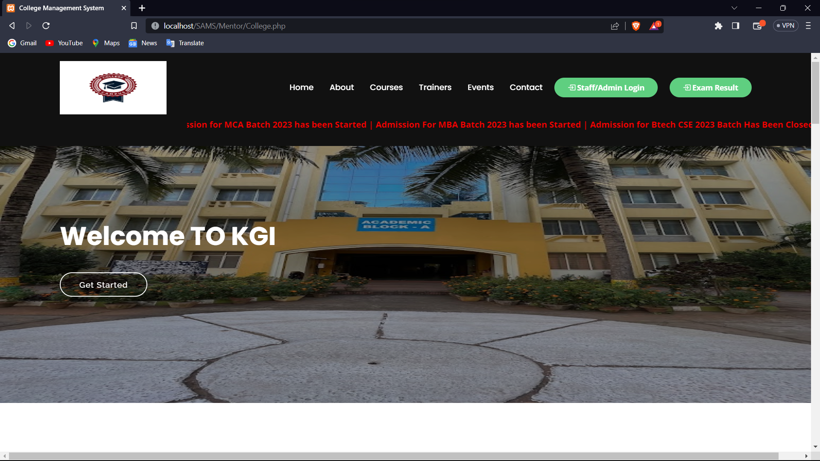

**Login Page :- Admin /Teacher**

<?php

include 'Includes/dbcon.php';

session_start();

?>

<!DOCTYPE html>

<html lang="en">

<head>

    <meta charset="utf-8">

    <meta http-equiv="X-UA-Compatible" content="IE=edge">

    <meta name="viewport" content="width=device-width, initial-scale=1, shrink-to-fit=no">

    <meta name="description" content="">

    <meta name="author" content="">

    <link href="img/logo/attnlg.jpg" rel="icon">

    <title>Login</title>

    <link href="vendor/fontawesome-free/css/all.min.css" rel="stylesheet" type="text/css">

    <link href="vendor/bootstrap/css/bootstrap.min.css" rel="stylesheet" type="text/css">

    <link href="css/ruang-admin.min.css" rel="stylesheet">

    <style>

  .ul {

  border: 1px solid black;

  list-style-type: none;

  margin: 0;

  padding: 0;

  overflow: hidden;

  background-color: rgb(46, 49, 57);

  }

 .ul> li {

  float: left;

  }

  .ul>li a {

  display: block;

  color: rgb(255, 255, 255);

  text-align: center;

  font-family: "Poppins", sans-serif;

  font-size: 15px;

  font-weight: 500;

  padding: 14px 16px;

  text-decoration: none;

  }

  .ul>li a:hover {

  background-color: rgb(248, 32, 32);

  }

</style>

</head>

<body class="bg-gradient-login" style="background-image: url('img/logo/loral1.jpe00g');">

<ul class="ul">

<li><a class="active" href="http://localhost/SAMS/Mentor/College.php">Home</a></li>

          <li><a href="http://localhost/SAMS/Mentor/about.php">About</a></li>

          <li><a href="http://localhost/SAMS/Mentor/courses.php">Courses</a></li>

          <li><a href="http://localhost/SAMS/Mentor/trainers.php">Trainers</a></li>

          <li><a href="http://localhost/SAMS/Mentor/events.php">Events</a></li>

          <li><a href="http://localhost/SAMS/Mentor/contact.php">Contact</a></li>

</ul>

    <!-- Login Content -->

    <div class="container-login">

        <div class="row justify-content-center">

            <div class="col-xl-10 col-lg-12 col-md-9">

                <div class="card shadow-sm my-5">

                    <div class="card-body p-0">

                        <div class="row">

                            <div class="col-lg-12">

                                <div class="login-form">

                                    <div class="text-center">

                                        <img src="https://thumbs.dreamstime.com/b/print-173909015.jpg" style="width:150px;height:150px">

                                        <br><br>

                                        <h1 class="h4 text-gray-900 mb-4">LOGIN PANEL</h1>

                                    </div>

                                    <form class="user" method="Post" action="">

                                        <div class="form-group">

                                            <select required name="userType" class="form-control mb-3">

                                                <option value="">--Select User Roles--</option>

                                                <option value="Administrator">Administrator</option>

                                                <option value="ClassTeacher">ClassTeacher</option>

                                            </select>

                                        </div>

                                        <div class="form-group">

                                            <input type="text" class="form-control" required name="username" id="exampleInputEmail" placeholder="Enter Email Address">

                                        </div>

                                        <div class="form-group">

                      </div>

                    </div>

                </div>

            </div>

        </div>

    </div>

    <!-- Login Content -->

    <script src="vendor/jquery/jquery.min.js"></script>

    <script src="vendor/bootstrap/js/bootstrap.bundle.min.js"></script>

    <script src="vendor/jquery-easing/jquery.easing.min.js"></script>

    <script src="js/ruang-admin.min.js"></script>

</body>

</html>

**Output: -**

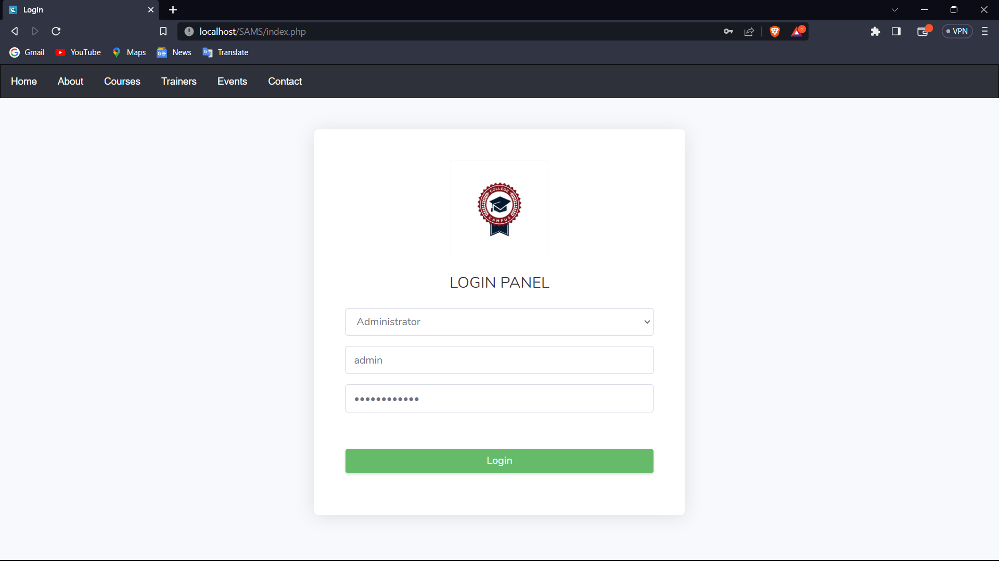

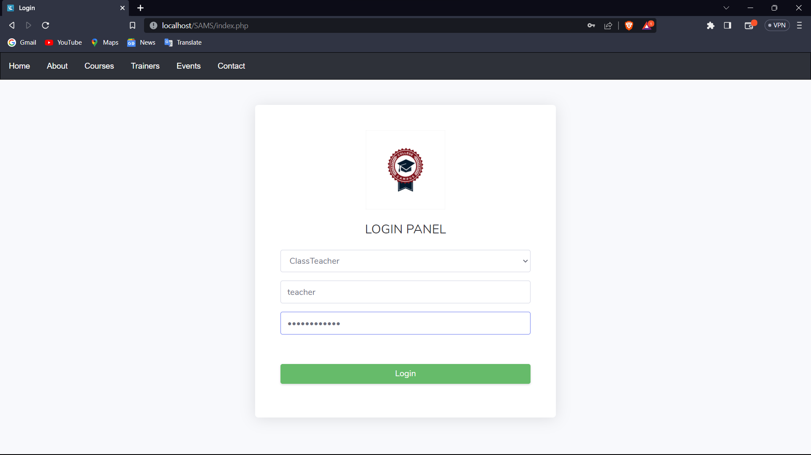

**Admin DashBoard**:- <http://localhost/SAMS/Admin/index.php>

<?php

include '../Includes/dbcon.php';

include '../Includes/session.php';

    $query = "SELECT tblclass.className,tblclassarms.classArmName

    FROM tblclassteacher

    INNER JOIN tblclass ON tblclass.Id = tblclassteacher.classId

    INNER JOIN tblclassarms ON tblclassarms.Id = tblclassteacher.classArmId

    Where tblclassteacher.Id = '$_SESSION[userId]'";

    $rs = $conn->query($query);

    $num = $rs->num_rows;

    $rrw = $rs->fetch_assoc();

?>

<!DOCTYPE html>

<html lang="en">

<head>

  <meta charset="utf-8">

  <meta http-equiv="X-UA-Compatible" content="IE=edge">

  <meta name="viewport" content="width=device-width, initial-scale=1, shrink-to-fit=no">

  <meta name="description" content="">

  <meta name="author" content="">

  <link href="img/logo/attnlg.jpg" rel="icon">

  <title>Dashboard</title>

  <link href="../vendor/fontawesome-free/css/all.min.css" rel="stylesheet" type="text/css">

  <link href="../vendor/bootstrap/css/bootstrap.min.css" rel="stylesheet" type="text/css">

  <link href="css/ruang-admin.min.css" rel="stylesheet">

</head>

<body id="page-top">

  <div id="wrapper">

    <!-- Sidebar -->

   <?php include "Includes/sidebar.php";?>

    <!-- Sidebar -->

    <div id="content-wrapper" class="d-flex flex-column">

      <div id="content">

        <!-- TopBar -->

           <?php include "Includes/topbar.php";?>

        <!-- Topbar -->

        <!-- Container Fluid-->

        <div class="container-fluid" id="container-wrapper">

          <div class="d-sm-flex align-items-center justify-content-between mb-4">

            <h1 class="h3 mb-0 text-gray-800">Administrator Dashboard</h1>

            <ol class="breadcrumb">

              <li class="breadcrumb-item"><a href="./">Home</a></li>

              <li class="breadcrumb-item active" aria-current="page">Dashboard</li>

            </ol>

          </div>

          <div class="row mb-3">

          <!-- Students Card -->

          <?php

$query1=mysqli_query($conn,"SELECT * from tblstudents");

$students = mysqli_num_rows($query1);

?>

            <div class="col-xl-3 col-md-6 mb-4">

              <div class="card h-100">

                <div class="card-body">

                  <div class="row no-gutters align-items-center">

                    <div class="col mr-2">

                      <div class="text-xs font-weight-bold text-uppercase mb-1">Students</div>

                      <div class="h5 mb-0 mr-3 font-weight-bold text-gray-800"><?php echo $students;?></div>

                      <div class="mt-2 mb-0 text-muted text-xs">

                        <!-- <span class="text-success mr-2"><i class="fas fa-arrow-up"></i> 20.4%</span>

                        <span>Since last month</span> -->

                                    <!-- <span class="text-success mr-2"><i class="fas fa-arrow-up"></i> 12%</span>

                                    <span>Since last years</span> -->

                                  </div>

                                </div>

                                <div class="col-auto">

                                  <i class="fas fa-chalkboard-teacher fa-2x text-danger"></i>

                                </div>

                              </div>

                            </div>

                          </div>

                        </div>

                         <!-- Session and Terms Card  -->

            <?php

            $query1=mysqli_query($conn,"SELECT * from tblsessionterm");

            $sessTerm = mysqli_num_rows($query1);

            ?>

                        <div class="col-xl-3 col-md-6 mb-4">

                          <div class="card h-100">

                            <div class="card-body">

                              <div class="row no-gutters align-items-center">

                                <div class="col mr-2">

                                  <div class="text-xs font-weight-bold text-uppercase mb-1">Session & Terms</div>

                                  <div class="h5 mb-0 font-weight-bold text-gray-800"><?php echo $sessTerm;?></div>

                                  <div class="mt-2 mb-0 text-muted text-xs">

                                    <!-- <span class="text-success mr-2"><i class="fas fa-arrow-up"></i> 12%</span>

                                    <span>Since last years</span> -->

                                  </div>

                                </div>

                                <div class="col-auto">

                                  <i class="fas fa-calendar-alt fa-2x text-warning"></i>

                                </div>

                              </div>

                            </div>

                          </div>

                        </div>

                        <!-- Terms Card  -->

            <?php

            $query1=mysqli_query($conn,"SELECT * from tblterm");

            $termonly = mysqli_num_rows($query1);

            ?>

                        <div class="col-xl-3 col-md-6 mb-4">

                          <div class="card h-100">

                            <div class="card-body">

                              <div class="row no-gutters align-items-center">

Output :-

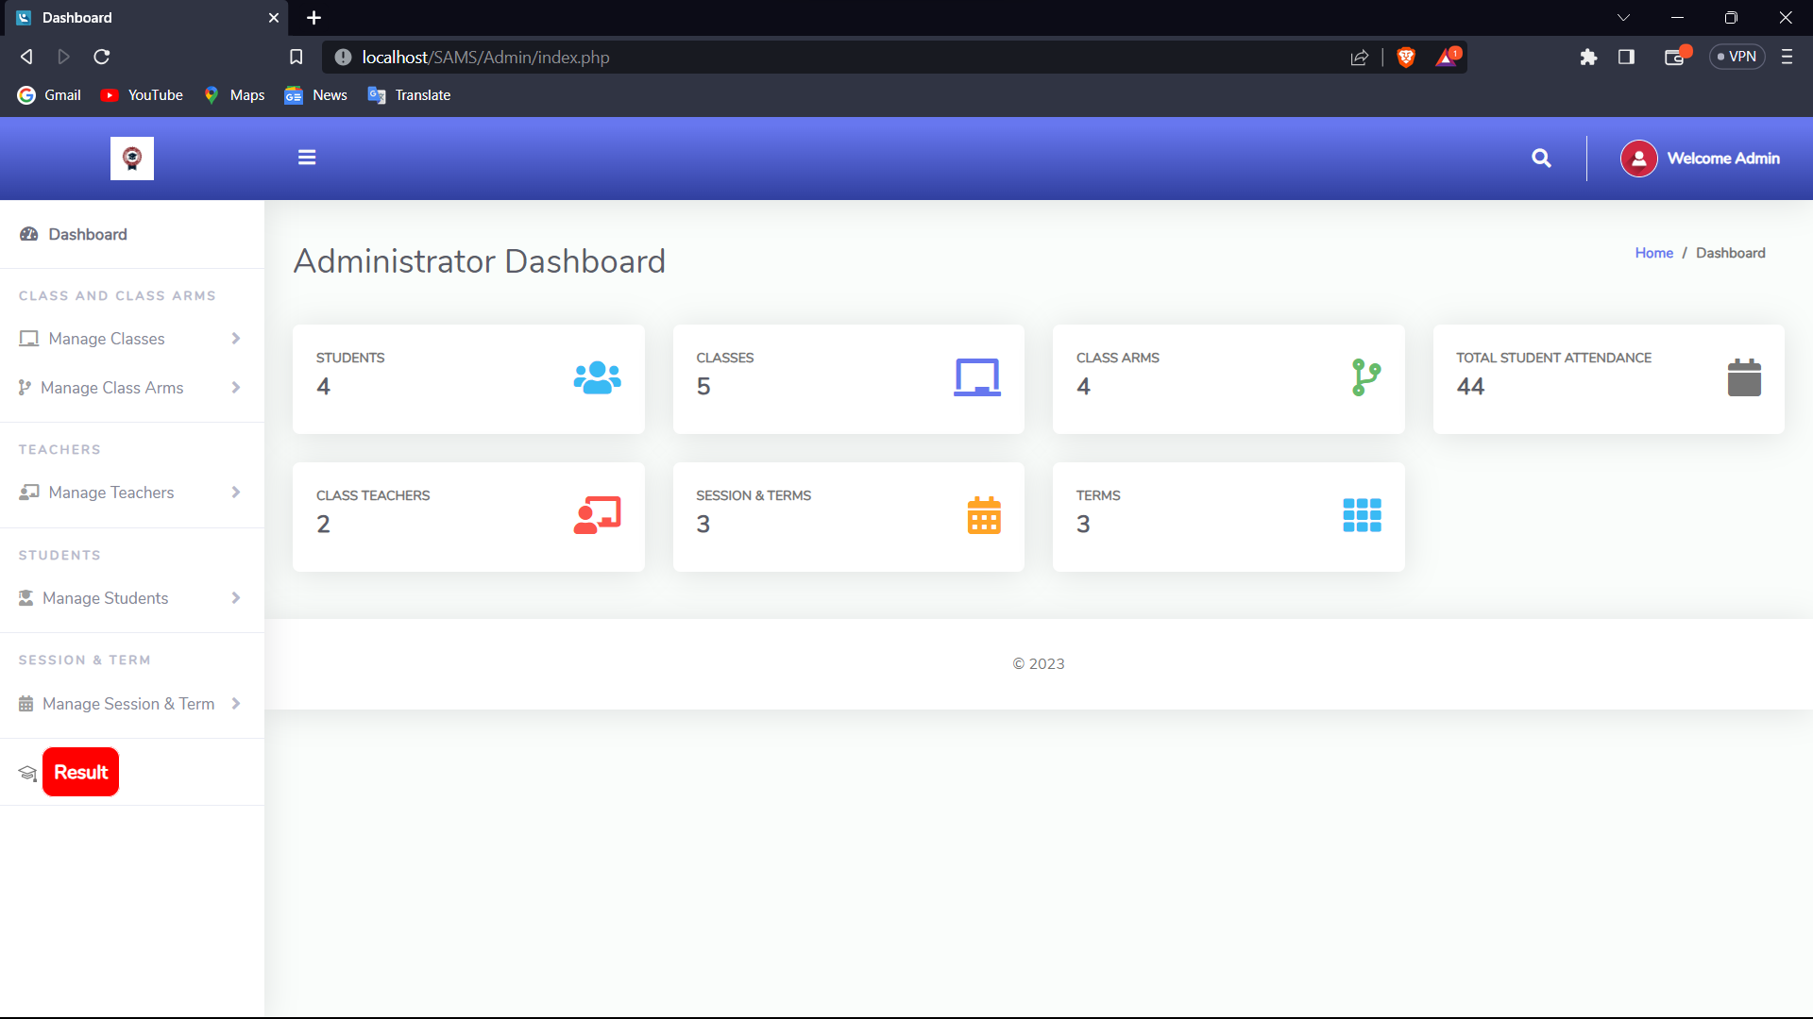

Student Result Enter Page by Admin: - <http://localhost/SAMS/SRMS/login.php>

<!DOCTYPE html>

<html lang="en">

<head>

    <meta charset="UTF-8">

    <meta name="viewport" content="width=device-width, initial-scale=1.0">

    <title>Index Page</title>

    <link rel="stylesheet" href="css/login.css">

    <link rel="stylesheet" href="./font-awesome-4.7.0/css/font-awesome.css">

    <link href="https://fonts.googleapis.com/css?family=Roboto" rel="stylesheet">

    <style>

        .main{

            margin-top: -80px;

            margin-left: 500px;

        }

    </style>

</head>

<body onload="window.alert('Admin Has To Login Again !')" >

    <div class="title">

        <span>Enter Result </span>

        <a class="backbtn" href="http://localhost/SAMS/Admin/index.php" style="border: 1px solid;color:white;background-color:red;text-decoration:none;padding:5px;margin-top:0px;margin-left:0px;display:block;width:5%; font-size:17px;">BACK</a>

    </div>

    <div class="main">

        <div class="login">

            <form action="" method="post" name="login">

                <fieldset>

                    <legend class="heading">Admin Login</legend>

                    <input type="text" name="userid" placeholder="Username" autocomplete="off">

                    <input type="password" name="password" placeholder="Password" autocomplete="off">

                    <input type="submit" value="Login">

                </fieldset>

            </form>

        </div>

       </div>

</body>

</html>

<?php

    include("init.php");

    session_start();

    if (isset($_POST["userid"],$_POST["password"]))

    {

        $username=$_POST["userid"];

        $password=$_POST["password"];

        $sql = "SELECT userid FROM admin_login WHERE userid='$username' and password = '$password'";

        $result=mysqli_query($conn,$sql);

        // $row=mysqli_fetch_array($result);

        $count=mysqli_num_rows($result);

        if($count==1) {

            $_SESSION['login_user']=$username;

            header("Location: dashboard.php");

        }else {

            echo '<script language="javascript">';

            echo 'alert("Invalid Username or Password")';

            echo '</script>';

        }

    }

?>

Output:-

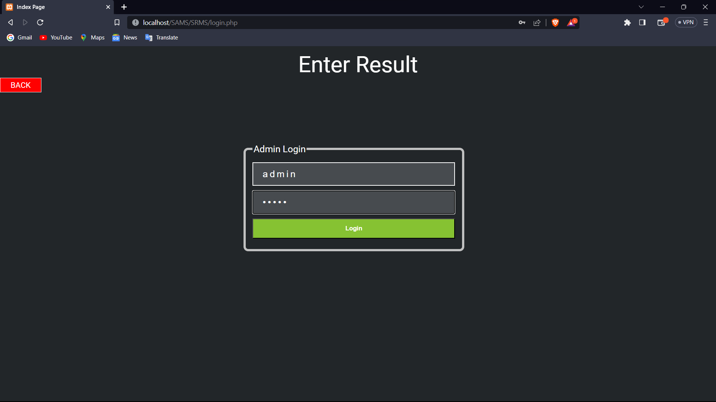

After Login:- Admin Can Enter Result Of Internal Exam

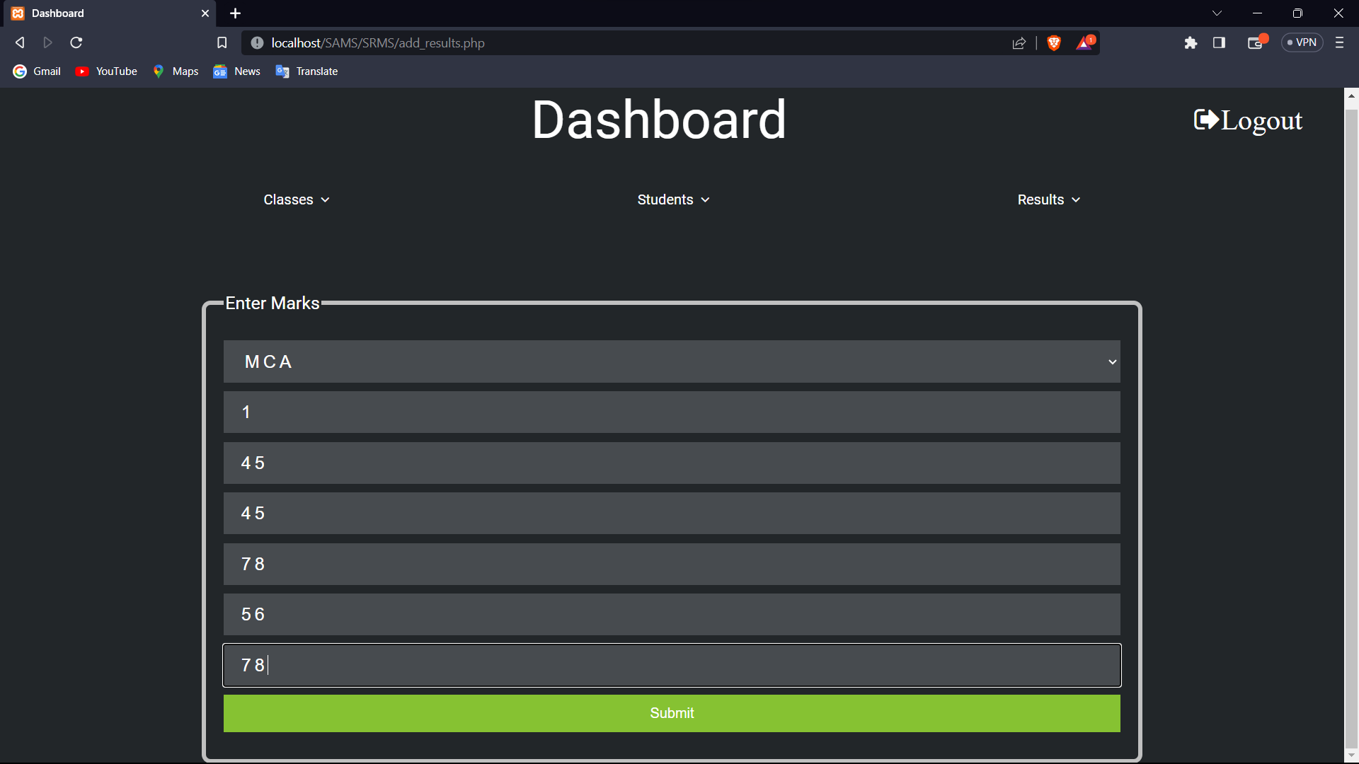

After Login Teacher Interface:-

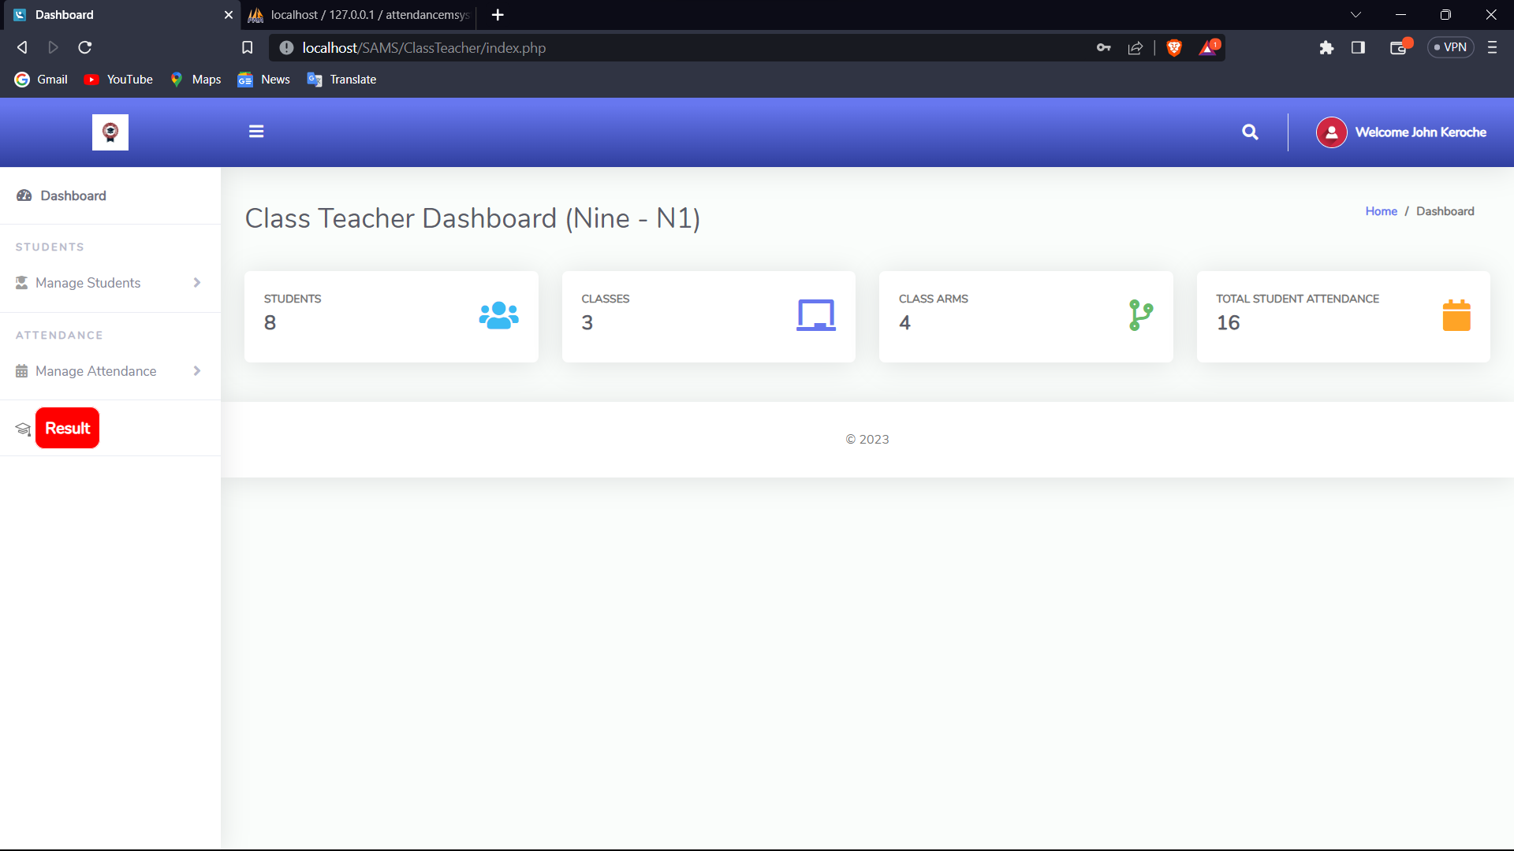

Student Attendance :

<?php

error_reporting(0);

include '../Includes/dbcon.php';

include '../Includes/session.php';

?>

<!DOCTYPE html>

<html lang="en">

<head>

  <meta charset="utf-8">

  <meta http-equiv="X-UA-Compatible" content="IE=edge">

  <meta name="viewport" content="width=device-width, initial-scale=1, shrink-to-fit=no">

  <meta name="description" content="">

  <meta name="author" content="">

  <link href="img/logo/attnlg.jpg" rel="icon">

  <title>Dashboard</title>

  <link href="../vendor/fontawesome-free/css/all.min.css" rel="stylesheet" type="text/css">

  <link href="../vendor/bootstrap/css/bootstrap.min.css" rel="stylesheet" type="text/css">

  <link href="css/ruang-admin.min.css" rel="stylesheet">

<script>

    function typeDropDown(str) {

    if (str == "") {

                    <div class="form-group row mb-3">

                        <div class="col-xl-6">

                      <tr>

                        <th>#</th>

                        <th>First Name</th>

                        <th>Last Name</th>

                        <th>Other Name</th>

                        <th>Admission No</th>

                        <th>Class</th>

                        <th>Class Arm</th>

                        <th>Session</th>

                        <th>Term</th>

                        <th>Status</th>

                        <th>Date</th>

                      </tr>

                    </thead>

                    <tbody>

                  <?php

                    if(isset($_POST['view'])){

                       $admissionNumber =  $_POST['admissionNumber'];

                       $type =  $_POST['type'];

                       if($type == "1"){ //All Attendance

                        $query = "SELECT tblattendance.Id,tblattendance.status,tblattendance.dateTimeTaken,tblclass.className,

                        tblclassarms.classArmName,tblsessionterm.sessionName,tblsessionterm.termId,tblterm.termName,

                        tblstudents.firstName,tblstudents.lastName,tblstudents.otherName,tblstudents.admissionNumber

                        FROM tblattendance

                        INNER JOIN tblclass ON tblclass.Id = tblattendance.classId

                        INNER JOIN tblclassarms ON tblclassarms.Id = tblattendance.classArmId

                        INNER JOIN tblsessionterm ON tblsessionterm.Id = tblattendance.sessionTermId

                        INNER JOIN tblterm ON tblterm.Id = tblsessionterm.termId

                        INNER JOIN tblstudents ON tblstudents.admissionNumber = tblattendance.admissionNo

                        where tblattendance.admissionNo = '$admissionNumber' and tblattendance.classId = '$_SESSION[classId]' and tblattendance.classArmId = '$_SESSION[classArmId]'";

                       }

                       if($type == "2"){ //Single Date Attendance

                          {

</div>

  </div>

  <!-- Scroll to top -->

  <a class="scroll-to-top rounded" href="#page-top">

    <i class="fas fa-angle-up"></i>

  </a>

  <script src="../vendor/jquery/jquery.min.js"></script>

  <script src="../vendor/bootstrap/js/bootstrap.bundle.min.js"></script>

  <script src="../vendor/jquery-easing/jquery.easing.min.js"></script>

  <script src="js/ruang-admin.min.js"></script>

   <!-- Page level plugins -->

  <script src="../vendor/datatables/jquery.dataTables.min.js"></script>

  <script src="../vendor/datatables/dataTables.bootstrap4.min.js"></script>

  <!-- Page level custom scripts -->

  <script>

    $(document).ready(function () {

      $('#dataTable').DataTable(); // ID From dataTable

      $('#dataTableHover').DataTable(); // ID From dataTable with Hover

    });

  </script>

</body>

</html>

**Output:-**

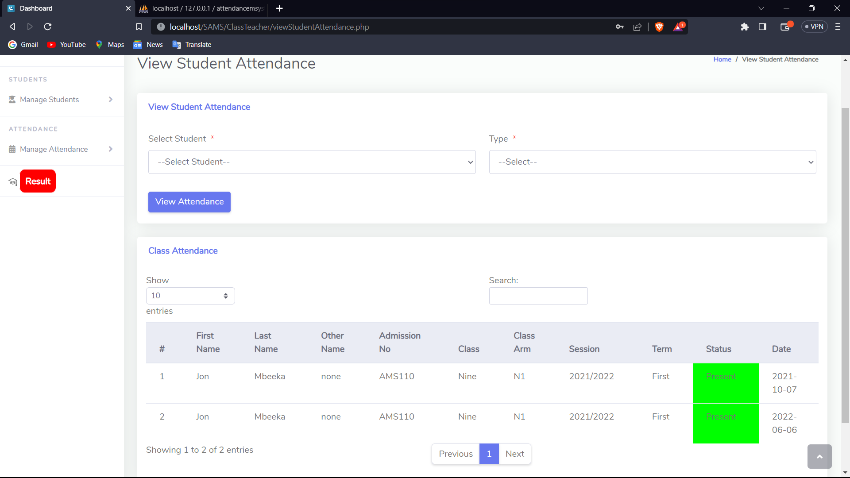

**View Student Result : -** Student Can Watch his/her Result By Entering Branch Name and Roll No.

<!DOCTYPE html>

<html lang="en">

<head>

    <meta charset="UTF-8">

    <meta name="viewport" content="width=device-width, initial-scale=1.0">

    <title>Index Page</title>

    <link rel="stylesheet" href="css/login.css">

    <link rel="stylesheet" href="./font-awesome-4.7.0/css/font-awesome.css">

    <link href="https://fonts.googleapis.com/css?family=Roboto" rel="stylesheet">

    <style>

      body{

        background-image: url('https://media.gettyimages.com/id/95011762/photo/college-students-checking-test-scores-in-corridor.jpg?s=612x612&w=0&k=20&c=DfWKGGjGnYWrME-nD9X1I36WjKlhjjcU2EkfO3B1214=');

        background-repeat: no-repeat;

        background-position-y:50px ;

        background-size:100% 720px;

      }

        .ul {

  border: 1px solid black;

  list-style-type: none;

  margin: 0;

  padding: 0;

  overflow: hidden;

  background-color: rgb(46, 49, 57);

  }

 .ul> li {

  float: left;

  }

  .ul>li a {

  display: block;

  color: rgb(255, 255, 255);

  text-align: center;

  font-family: "Poppins", sans-serif;

  font-size: 15px;

  font-weight: 500;

  padding: 14px 16px;

  text-decoration: none;

  }

  .ul>li a:hover {

  background-color: rgb(248, 32, 32);

  }

  input[type=reset]{

    /* background-color: #474b4f; */

    color: black;

    border: none;

    transition-duration: 0.4s;

    cursor: pointer;

    font-size: 16px;

<legend class="heading" style="color: yellow;font-weight:bold;">For Students</legend>

                    <?php

                        include('init.php');

                        $class_result=mysqli_query($conn,"SELECT `name` FROM `class`");

                            echo '<select name="class">';

                            echo '<option selected disabled>Select Class</option>';

                        while($row = mysqli_fetch_array($class_result)){

                            $display=$row['name'];

                            echo '<option value="'.$display.'">'.$display.'</option>';

                        }

                        echo'</select>'

                    ?>

<input type="text" name="rn" placeholder="Roll No">

                    <input type="submit" value="Get Result">

                    <input type="reset" value="Reset">

                </fieldset>

            </form>

        </div>

</body>

</html>

**Output: -**

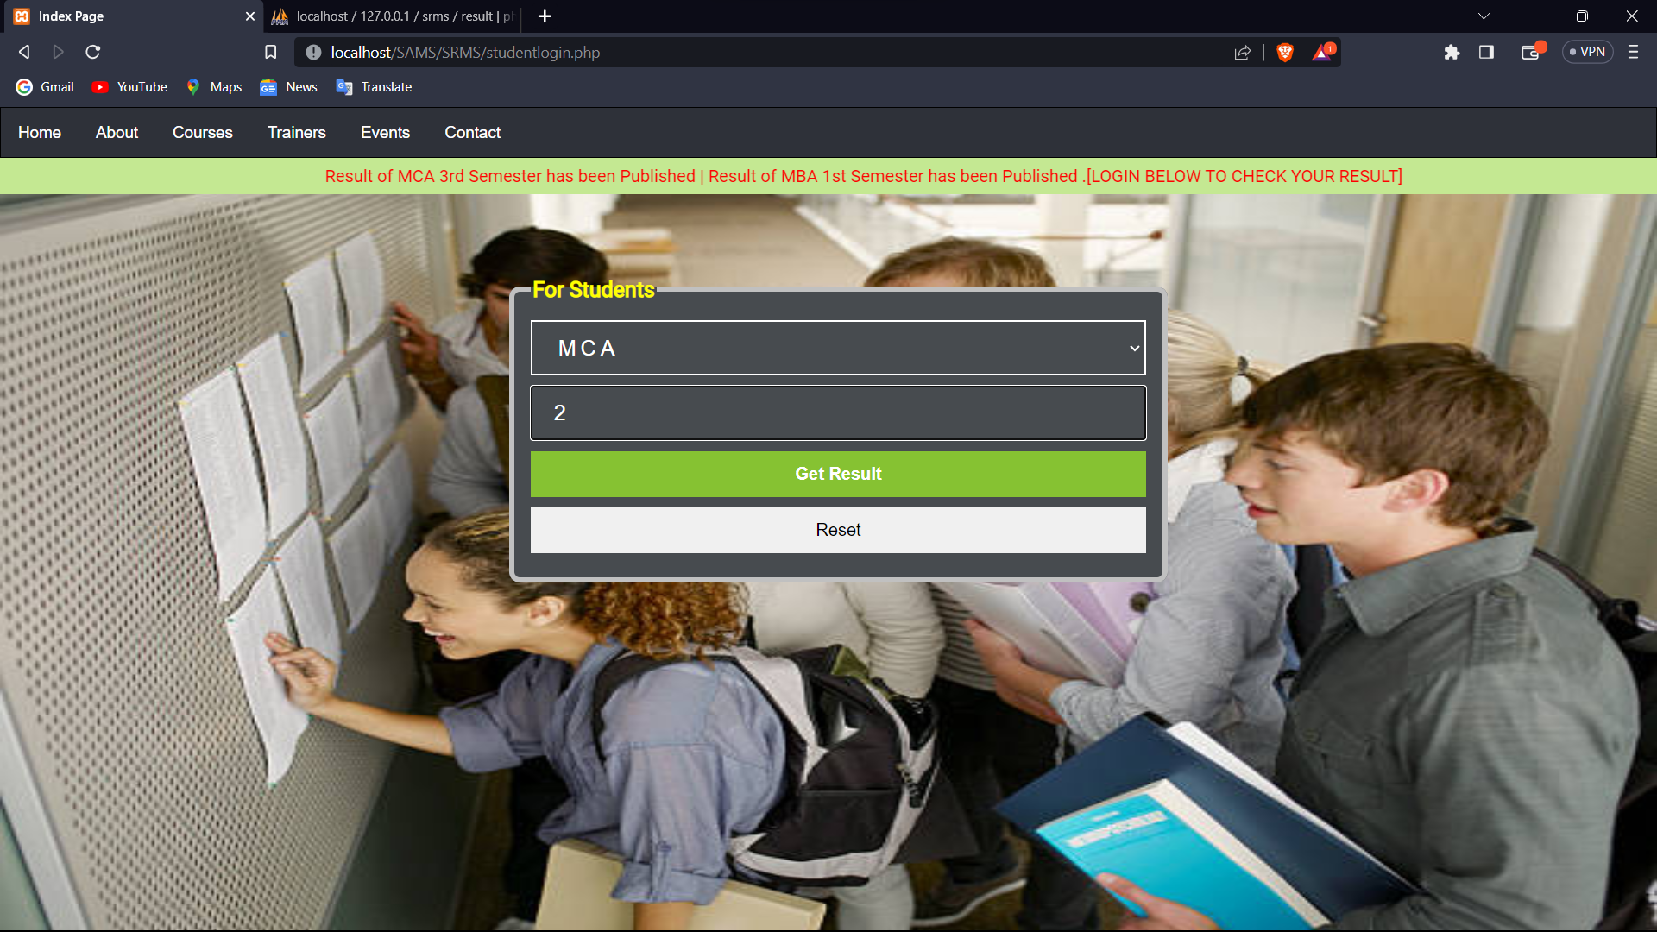

**After Clicking on Get Result :-**

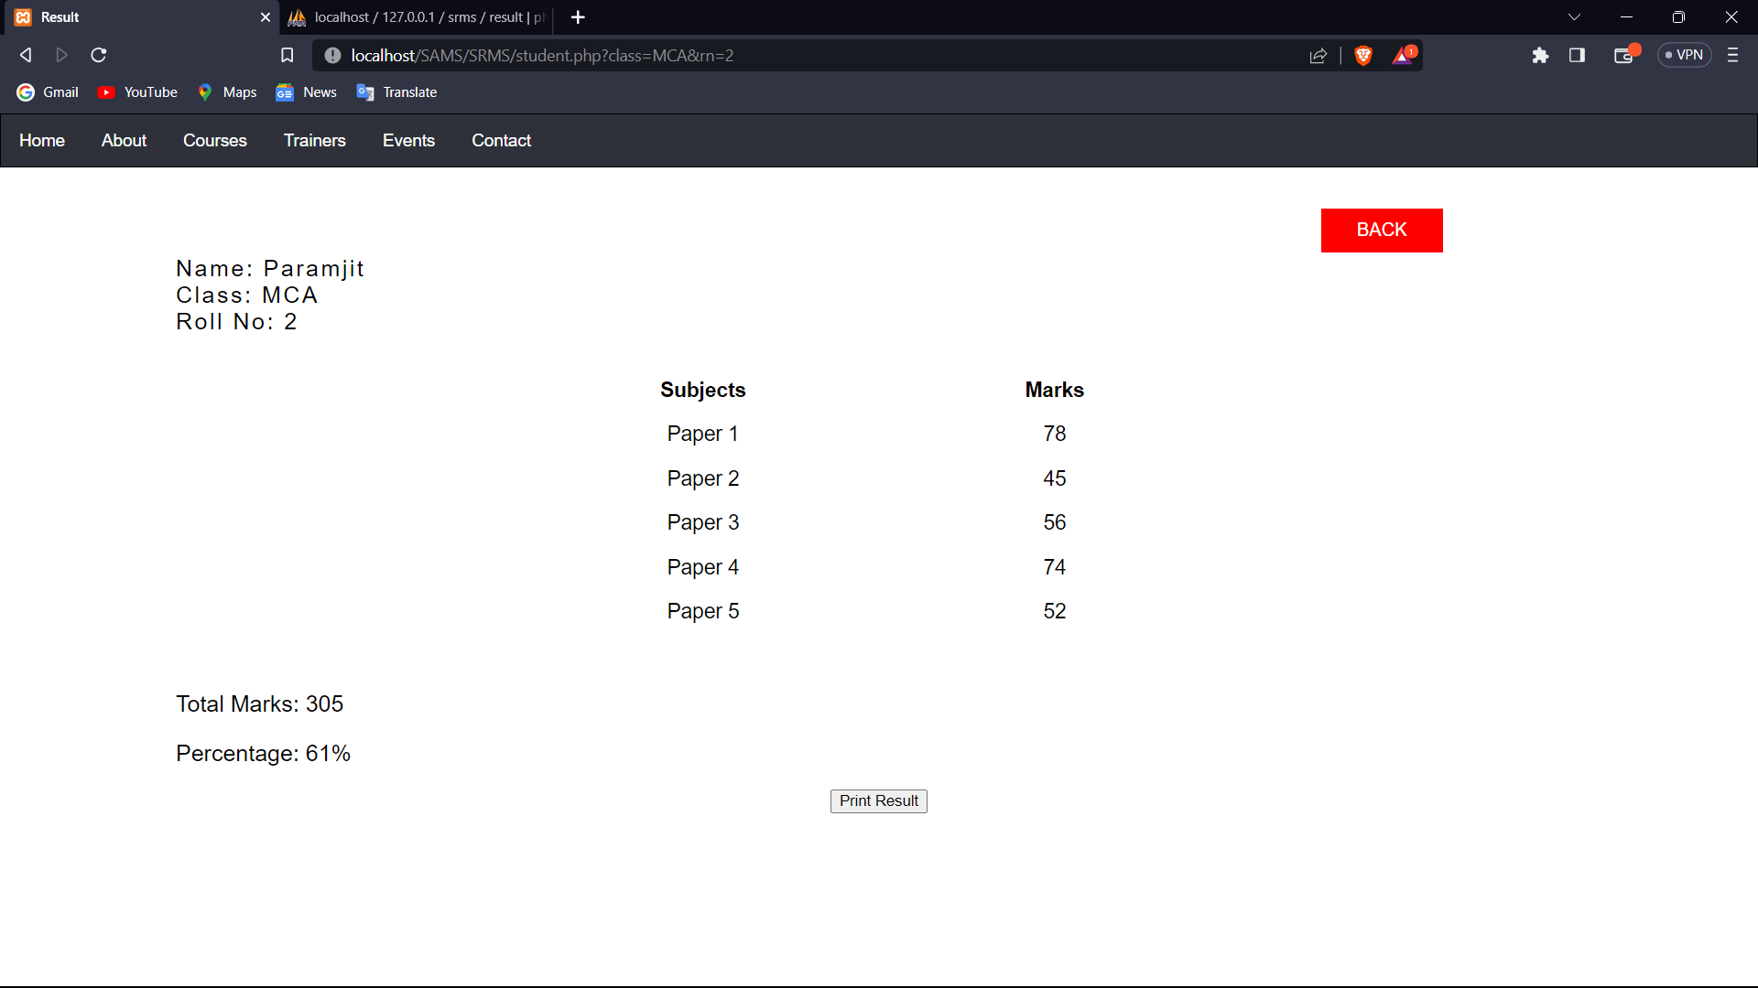

**Student Can Print or Save Its Result By clicking on Print Result Button:**

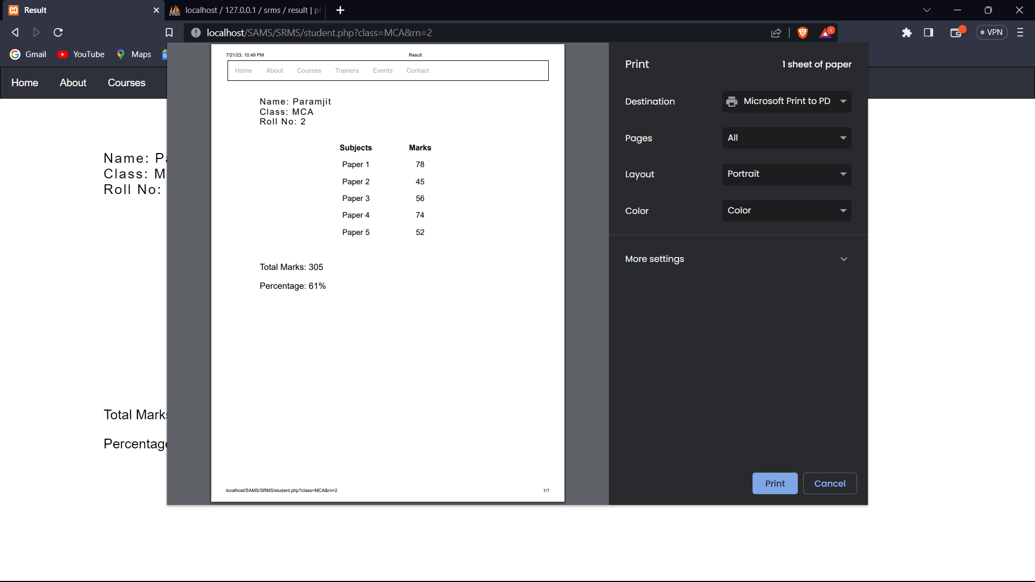

**Conclusion**

The College Management System developed using PHP is an effective and robust solution to streamline various administrative tasks and enhance the overall efficiency of the college. This system provides a user-friendly interface that allows administrators, faculty, and students to interact with the platform seamlessly. After implementing the College Management System, several key conclusions can be drawn:

1. **Improved Administrative Efficiency**: The College Management System significantly reduces manual paperwork and administrative efforts. It automates tasks like student registration, course management, attendance tracking, fee management, and generates various reports. As a result, administrative staff can focus on more critical tasks, ultimately improving overall efficiency.
2. **Enhanced Student Experience**: The system offers students easy access to important information such as class schedules, examination details, grades, and announcements. This accessibility leads to a better student experience and increases their engagement with the college's academic and extracurricular activities.
3. **Efficient Communication**: The system facilitates seamless communication between students, faculty, and administrators. Students can interact with instructors, submit assignments online, and get timely feedback. Likewise, faculty members can communicate with students and other faculty, sharing updates and academic materials.
4. **Streamlined Academic Processes**: With features like course registration, grade management, and exam scheduling, academic processes are streamlined and organized. This leads to better planning and execution of academic activities.
5. **Data Management and Analysis**: The College Management System collects and stores valuable data related to students' performance, attendance, and other academic records. This data can be used to generate insightful reports and analytics, aiding in decision-making and identifying areas for improvement.
6. **Improved Financial Management**: The system handles fee management and tracks payments efficiently, reducing the chances of errors and financial discrepancies. It helps the college maintain better financial records and ensures timely fee collection.
7. **Scalability and Flexibility**: The PHP-based College Management System is easily scalable to accommodate the growing needs of the college. It can be customized and expanded to incorporate additional features or adapt to changing requirements.
8. **Data Security**: Implementing appropriate security measures, such as encryption and user authentication, ensures that sensitive data is protected from unauthorized access and potential security breaches.

In conclusion, the College Management System built with PHP brings significant benefits to the college community by optimizing administrative processes, fostering better communication, and enhancing the overall academic experience for students and faculty. The system's successful implementation leads to increased productivity, improved decision-making, and ultimately contributes to the growth and success of the college.

**REFERENCES**

1. S.R.Bharamagoudar, Geeta R.B., S.G.Totad “Web Based Student Information Management System”, International Journal of Advanced Research in Computer and Communication Engineering -June 2013, ISSN : 2319-5940.
2. Siddhant Gokule, Rohit Jadhav, Mruganayani Mane, Sanchita Chhajed “An Application to Enhance the Admission Process and Communication between Members of an Institute”, International Journal on Recent and Innovation Trends in Computing and Communication- ISSN: 2321-8169.
3. Miss. Namrata N. Shahade, Miss. Priya A. Kawade, Mr. Satish L. Thombare “Student Attendance Tracker System in Android”, INTERNATIONAL JOURNAL FOR ENGINEERING APPLICATIONS AND TECHNOLOGY- ISSN: 2321-8134.
4. Srikant Patnaik, Khushboo kumari Singh, Rashmi Ranjan, Niki Kumari,”College Management System”,in 2016,Dept of ECE,Orissa,e-ISSN: 2395-00556.
5. R. M. Leod, Management Information Systems, Third Ed., Science Research Associates, 1986, pp. 17-19.
6. L. Long, Management Information System, Prentice Hall, 1989, pp.116-11.